WS22

Aircraft Design Lecture Notes Summaries

Chapter 1: Introduction

Design Process
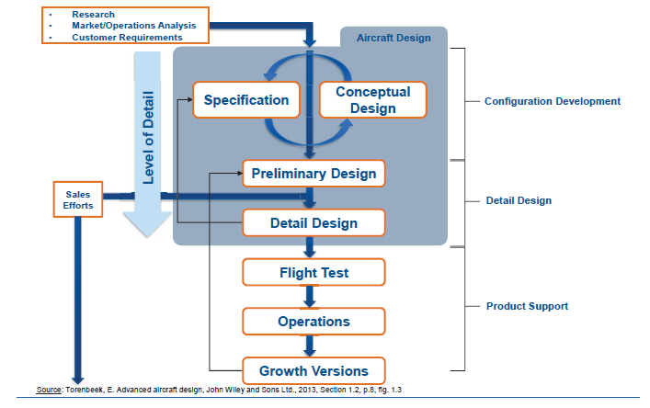
Design process of aircrafts start with researh, market/operations analysis and customers requirements then according to specifications, conceptual design start shaping but at the same time conceptual design drives the specifications. So, specifications and conceptual design are in loops in the first stage of design process. After that preliminary design process starts, then detail design, flight test, operations and growth version.
At the growth version process step, the design needs to turn back to preliminary design data. Because scope of growth is related with preliminary design parameters. Between preliminary design and detail design processes, performance guaranteed to customer and sales efforts start.

Top Level Requirements
Key requirements are: Flight Mach Number, Passenger Capacity and Flight Range. But other than that, following criterias are also important: Take off field length, time to climb, approach speed, ETOPS, hanger size, fuel reserve.
ETOPS: ETOPS is a conditions of aircraft that described the one of the engine of the aircraft failed and the aircraft is capable of fly some more time.
The design process is divided into 3 phases, Conceptual Design, Preliminary Design and Detail Design. In conceptual design process, the range, flight altitude, flight speed, mission requirements and material requirements are given and following results are expected: trade offs, technologies, cost goals, weight goals, lift and drag, airfoil type….
In preliminary design phase, aeroelastic requirements, strength requirements, cyclic fatigue requirements and sinusoidal fatigue strength is given and following results are expected: design freeze, external configuration, basic internal configuration, camber and twist, main loads, stress and bending.
In the last phase of design process, detail design, local streght requirements, production capabilities, functional requirements are given and construction of indiviual parts, manufacturing process, assembly lines, design optimization through test results are expected results.

Chapter 2: Aerodynamics

Lift
Main lift principles are: Buoyancy(density difference), potential lift(unseperated, linear flow), vortex lift(high angle of attack sharp LE, vortexis created by purpose), compression lift (super-hypersonic wave rider, faster the air vehicle get, more lift will be generated).

Wing Geometry
Span: b, Reference Area: Sref, Aspect Ratio: b^2/Sref, tip chord: ctip, root chort: croot, taper ratio: ctip/croot, relative thickness t/c,and leading edge sweep are important parameters of wing geometry. Also local chord at kink: ckink, incidence angle iw, geometric twist et, dihedral angle, mean aerodynamic chord and wing apex location are important parameters.
The angle of attack at the wing tip is typically higher than at the wing root because the air moving over the wing tip is moving at a slower speed and experiences less resistance. This results in a higher lift coefficient and greater maneuverability at the wing tip. However, if the angle of attack becomes too high, it can cause the wing to stall, so pilots must be careful to stay within the safe angle of attack range during flight. Additionally, the wing tip also generates less induced drag, which is the drag caused by the wing creating lift, which makes the wing tip to have higher angle of attack.

Different Wing Configurations – Cons Pros
There are 3 typical wing configuration is shared in lecture. Low wing, midwing and hight wing configurations. These wing configurations are compared in terms of landing gear integration, payload are obstruction, interference drag, cargo accessibility, ground clearence for engines.
Landing gear integration: Landing gear integration is simplest in low wing configuration because landing gears are attached to wing and structural integraty becomes easy. Landing gear integration of high wing configuration is hard because an additional structure is needed between landing gear and wing to ensure structural continuity.
Payload (Cabin) Area Obstruction: Since low wing configuration is actively being used for commercial activies, it s the best option. Then high wing configuration and mid wing configuration comes.
Interference Drag: The high wing configuration has undisturbed wing area on the top of aircraft. Even though it s has high interference effect under the wing, it shows the best performance among options. Then lower wing configuration comes and lastly, mid wing configuration. Since mid wing configuration has 2 interference between the fuselage, this increases the amount of inference drag.
Cargo Capacity: Cargo capacity of the high wing highest then low wing and lastly midwing

